Vim

1-vim mycv

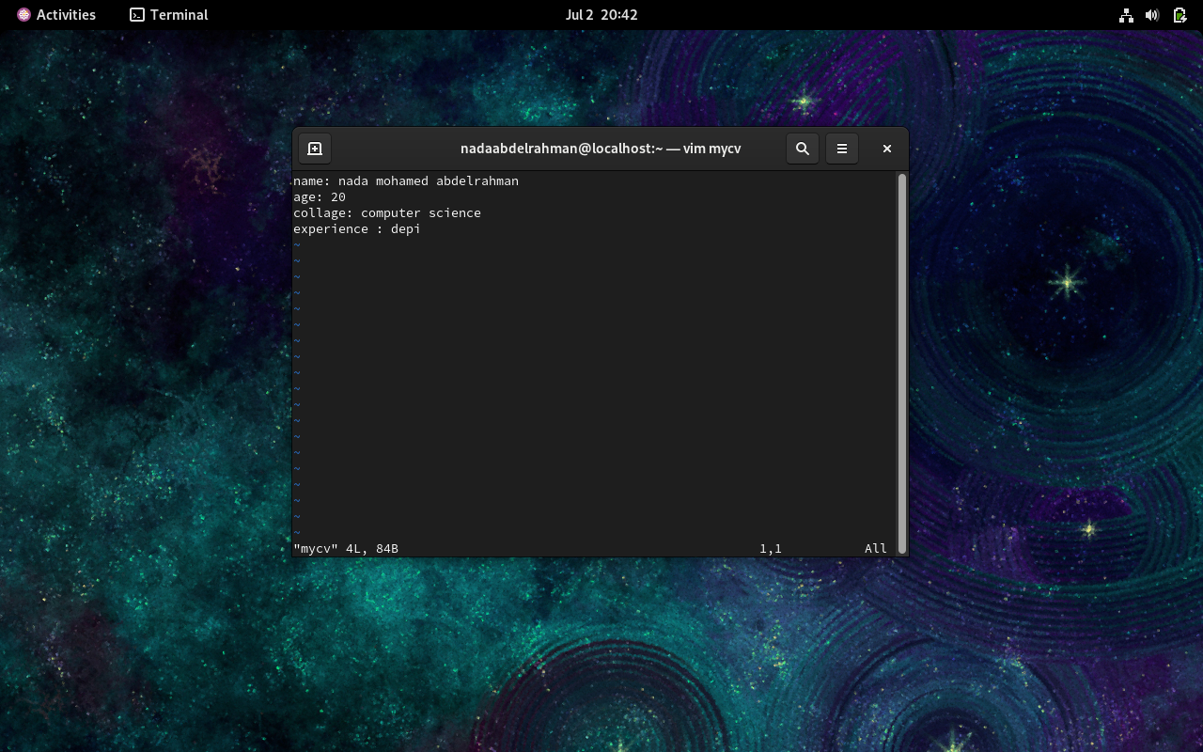

2- down “j”

Up “k”

5- 5 +shift+ g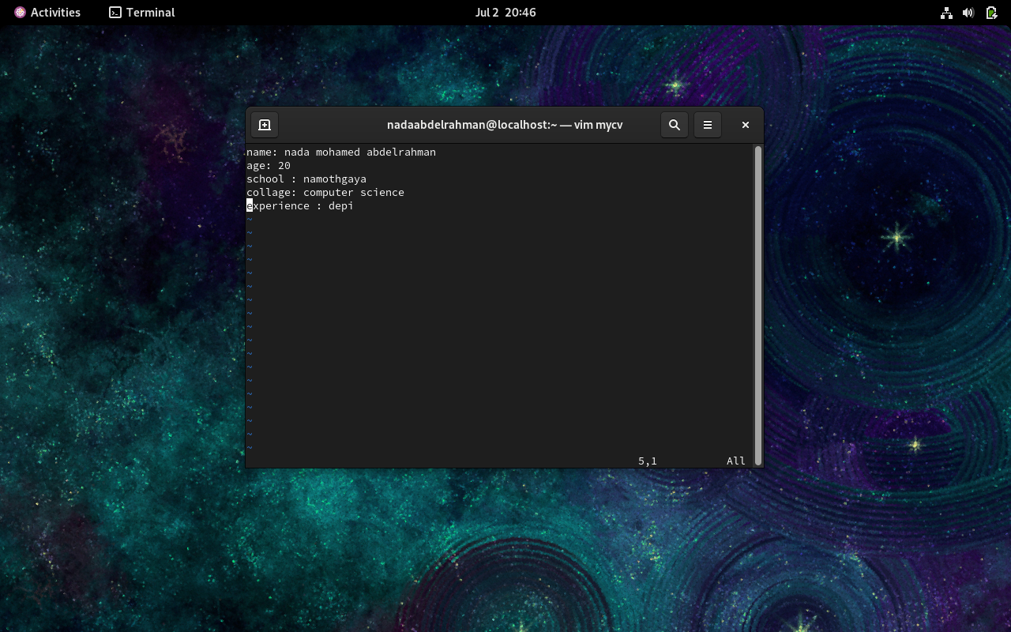

6-shift +a to step to end